Section:
- Safety Shoes
- Safety Glasses
- Work Gloves
- Designated Safety Areas
- Hearing Protection

Policy:

- Safety Shoes

Steel-toed work boots or shoes are a requirement for all Giles Chemical Corporation Management, Plant, and Repack employees who work in the designated areas denoted by posted "Designated Safety Area" diagram. Giles will reimburse employees for one pair of safety shoes every year up to fifty dollars ($50) or twenty-five dollars ($25) twice a year. Upon submission of the receipt to the Quality/Safety Manager, the receipt will be processed for reimbursement of funds to the employee. The payables process will generally take a week to ten days.

Administrative employees that do not consistently work in the manufacturing areas will not be required to wear steel-toed shoes or work boots. They are required to stay within the designated safe areas that are out lined by the posted "Designated Safety Area" diagram.

- Safety Glasses

All Plant, Repack and office employees will be issued a pair of safety glasses. These glasses are to be worn in the designated areas and must be kept on company premises at all times. There are No exceptions to this policy. If an employee is found to be in violation, the appropriate corrective action will be taken.

Replacement of non-prescription glasses may be obtained from the Quality/Safety Manager or Quality Associate.

Giles will reimburse employees who require prescription glasses up to $225.00 for prescription safety glasses purchased through Wal-Mart’s Vision Center in Haywood County every two years. The glasses are to be chosen by the employee from the styles available through the contract. Prescription Glasses which are lost, broken or damaged during the two year period will be replaced by the employee at their own expense.

- Work Gloves

All Plant and Repack employees will be issued the appropriate gloves for their position. These gloves are to be worn by the employee at their discretion. Gloves must be initialed by the employee for identification purposes and must be kept on company premises at all times.

Hazardous materials gloves will be in the appropriate storage areas and ready for use by authorized personnel. Employees will be responsible for keeping these gloves clean and stored in the correct manner for ease of access.

- Designated Safety Areas

In the manufacturing facility there will be an area that will be outlined as a safe area by the attached "Designated Safety Area" diagram. In this area safety glasses must be worn but safety shoes may not be a requirement.

Those persons coming to work or leaving the plant at the end of their shift may use the designated pathways and are not required to wear their safety shoes but safety glasses are required.

Any and all persons not employed by Giles but entering the facility will be expected to follow the safety guidelines outlined by Giles. Contractors will be given a brief safety orientation before they will be allowed to perform their duties.

Truck drivers will be expected to follow the safety guidelines outlined by Giles. The truck drivers may use the restrooms and break room if needed. They must be escorted to and from the break room in the designated areas and not be allowed to venture through the plant.

- Hearing Protection

Proper hearing protection will be available to all employees. The proper procedure for wearing hearing protection will also be covered during the employee’s safety training. Additional hearing protection will be provided upon request.

Hearing protection must be worn in the areas requiring “Ear Protection”, such as the boiler room, screener area, etc. Failure to do so will result in the appropriate corrective action.

Designated Safety Areas

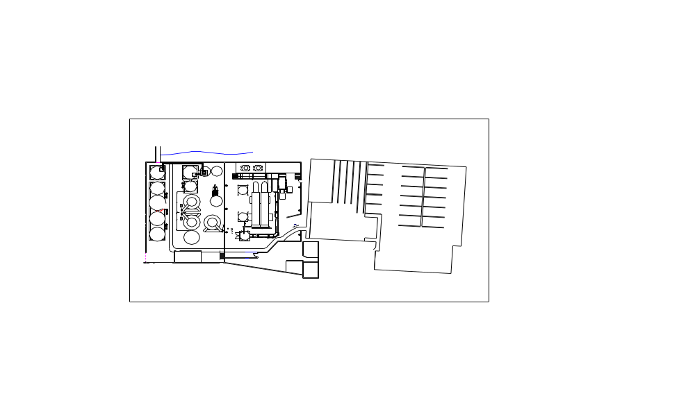

REVISION HISTORY

Revision Date Revision Number Revision Description

8/24/05 00 - Created new document

TRAINING DOCUMENTATION

 | EMPLOYEE | TITLE | SIGNATURE | DATE
1
2
3
4
5
6
7
8
9
10
11
12
13
14
15
16
17
18
19
20

